# Working on Markov Chain model

## Question 1:

## a). One Step Transition Matrix

[,1] [,2] [,3] [,4]

[1,] 0.6500 0.2275 0.1225 0.00

[2,] 0.4225 0.4375 0.0000 0.14

[3,] 0.3900 0.0000 0.4500 0.16

[4,] 0.0000 0.3600 0.2400 0.40

## (b). Calculate [p1(k) + p2(k)]*d1 + [p3(k) + p4(k)]*d2=E(k)

E(k) = 0.525

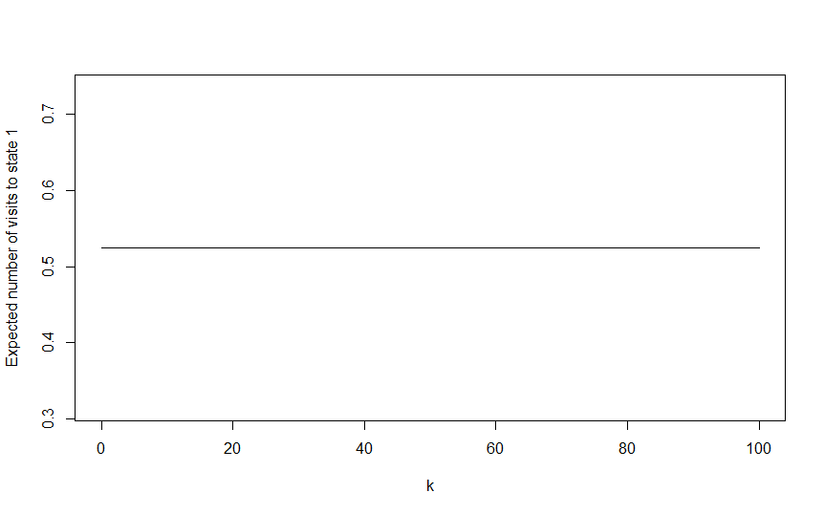

## ( c) Limiting Value

P*= 0.4849741, 0.2611399, 0.1523316, 0.1015544

## Question 2:

## a). One Step Transition Matrix

[,1] [,2] [,3] [,4] [,5] [,6]

[1,] 0.6400 0.2304 0.1296 0.0000 0.00 0.000

[2,] 0.6400 0.2304 0.0000 0.1296 0.00 0.000

[3,] 0.4096 0.2304 0.2160 0.0000 0.00 0.144

[4,] 0.3840 0.0000 0.0000 0.2160 0.24 0.000

[5,] 0.0000 0.0000 0.3600 0.0000 0.24 0.240

[6,] 0.0000 0.0000 0.0000 0.3600 0.00 0.240

## (b). Calculate [p1(k) + p2(k)]*d1 + [p3(k) + p4(k)]*d2=E(k)

E(k) = 0.3935557

## ( c) Limiting Value

P*= 0.58825523, 0.21399988, 0.10732423, 0.04861150, 0.01578112, 0.02602803